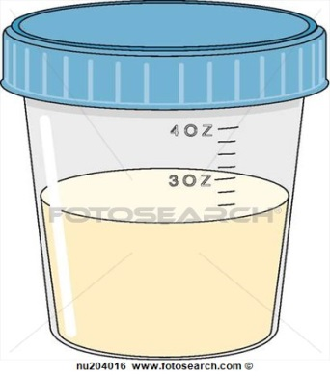Studholme Medical Centre
IMPORTANT INFORMATION
FOR PATIENTS WHO BRING IN URINE SAMPLES FOR TESTING
There have been important changes made to the way that the surgery now collects in Urine Samples for testing.
The decision to make these changes was made after analysing some recent research, which showed that the current system is not inline with best practice.
IN FUTURE WE WILL NOW ONLY ACCEPT URINE SPECIMENS AT RECEPTION WHICH:
- Have been requested by one of our GPs or minor illness nurse (we need to know who);
- Are accompanied by a completed Urine Sample Form from a hospital or health care professional or a Studholme symptom form has been completed

Please DO NOT bring down a urine sample unless you have been asked to by the Doctor or Minor Illness Nurse or you have symptoms.

PATIENTS WITH URINARY TRACT (WATER) INFECTIONS:

If you think that you are suffering from a Water Infection (UTI) please call the surgery to inform us of your symptoms. The reception team will then offer an appointment with our Minor Illness Nurse or arrange for the Duty GP to call you on the same day.

The most common symptoms of a Water Infection (UTI) include:
- Pain when passing urine
- Increased frequency of urination (going to the toilet more often)
- Passing small amounts of urine, but still feeling the need to urinate
- Appearance of blood in your urine
- Pain below your “Belly Button” or one sided pain in the mid back region
When you see the Minor Illness Nurse or the Duty Doctor telephones you, they will discuss your symptoms and treat the condition as appropriate. In most cases, this will be a course of antibiotics (not always necessary) and you may be asked to drop off a urine sample, but not in all cases.
So if you feel you have a Water Infection (UTI), please call the surgery first to tell us about your problem.

